How to Time Synchronize a PMC-53M in ION Enterprise

The PMC-53M meter has time registers providing timestamps for data logs. It can be time synchronized through communication.

This technical note describes how to time synchronize a PMC-53M in ION VISTA.

It assumes that the users are familiar with ION Enterprise Modbus Device Importer utility and Modbus register maps of PMC-53M.

**Reference documentation:**

* PMC-53 Series User Manual V.pdf
* Modbus_Device_Importer.pdf
* Modbus_and_ION_Technology.pdf
* ION_Enterprise_5.6_User_Guide.pdf

The PMC-53M meter’s serial port has been configured with the following parameters:

* Type = RS485
* Baud rate = 9600
* Data Bits = 8
* Parity = None
* Stop Bits = 1
* UnitID=100

**Creating the Modbus Map File for PMC-53M with ION Enterprise MDI Utility**

Use the ION Enterprise Modbus Device Importer utility to configure the PMC-53M Modbus device (mapping information) and add it as a Device Type to the Network Configuration database (NOM). All time registers need to be pre-defined in the Modbus map file (.ion).

1. Launch **Management Console**. Enter the right user name and password to login. Two default user names (“guest” and “supervisor”) are both with a default password of “0” (zero).
2. Navigate to **Tools**🡪**System**🡪**Modbus Device Importer…** from the Management Console user interface.

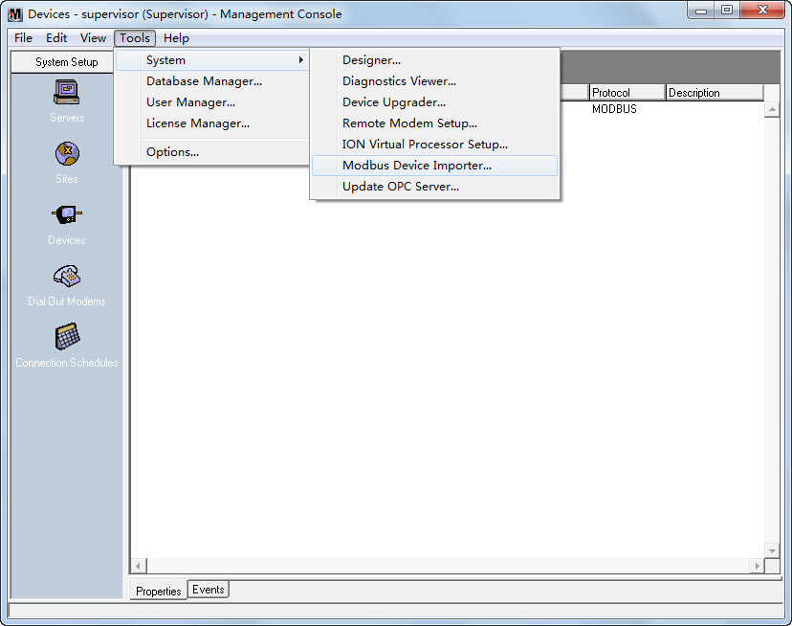

And the main console appears as follows (modbus_default.ion):

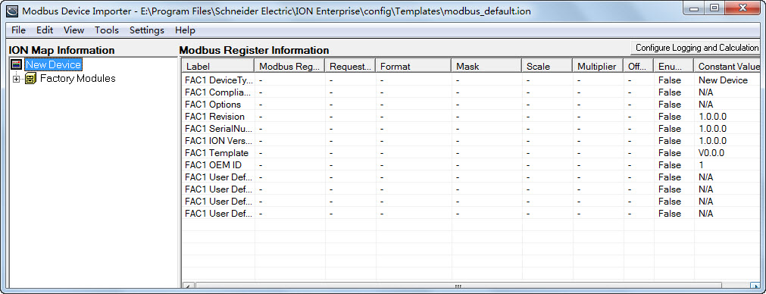

1. Right-click the **New Device** icon from the left pane in the **ION Map Information** region. Select **Advanced Properties** from the pop-up dialog box.

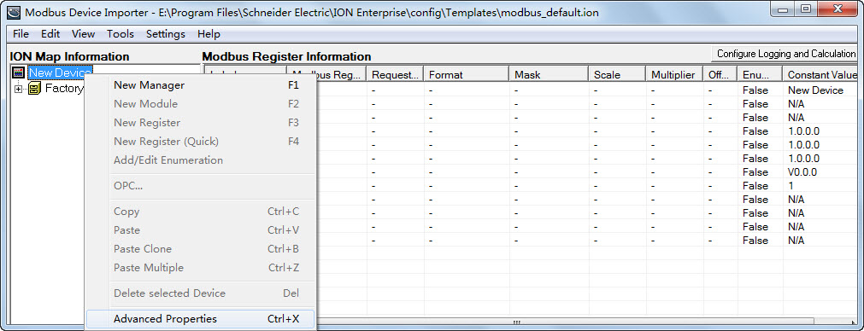

The **Device Properties** dialog box is shown as follows:

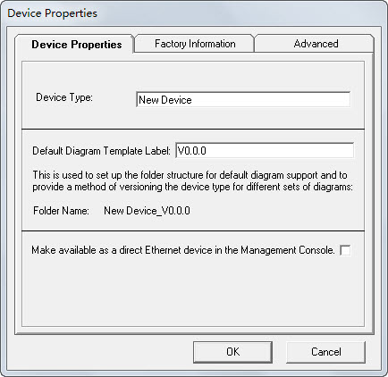

Configure the **Device Properties** according to your application.

**Device Properties Tab**

* **Device Type:** Type the name of the Device Type. For example, name the device as PMC53M if the device model is PMC-53M meter.
* **Default Diagram Template Label:** The string entered in this field is an internal identifier for the device.

Configure the **Device Properties** according to your application.

**Advanced Tab**

* **Device Type:** Type the name of the Device Type. For example, name the device as PMC53M if the device model is PMC-53M meter.
* **Multiple Preset Write check box:** Be sure that this check box is selected. PMC-53M requires Multiple Preset Write for time registers so that all time registers be written in a single transaction.

Other settings beneath this tab do not need to be changed.

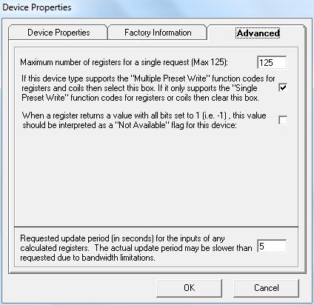

1. Right-click the **New Device** icon from the left pane in the **ION Map Information** region. Select **New Manager** from the pop-up dialog box.

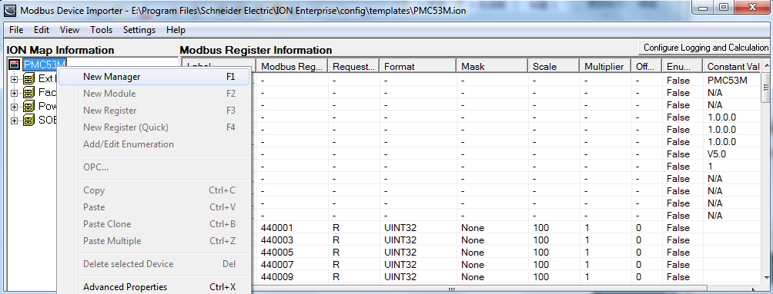

The **Add New Manager** dialog box appears.

Enter the new manager name into the **Manager Name** box and select External Numeric Manager type from the **Manager Type** drop-down button1. The manager type determines parameters in the modules and registers under it. The PMC-53M’s time registers are numeric registers.

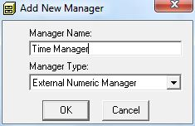

1. Right-click the **Manager** icon from the left pane in the **ION Map Information** region. Select **New Module** from the pop-up dialog box.

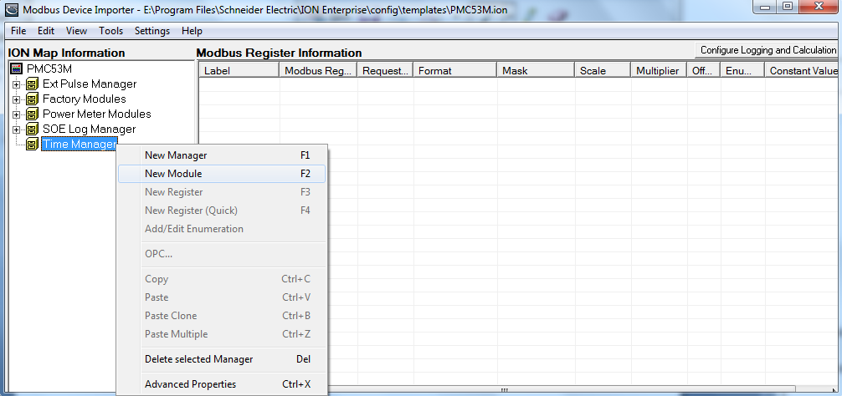

The **Add New Module** dialog box appears. Enter the new module name into the **Module Name** box and then click **OK**. For example, name the module as Clock Module to identify the time parameters.

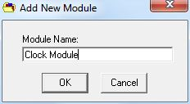

1. Right-click the **Module** icon from the left pane in the **ION Map Information** region. Select **New Register** from the pop-up dialog box.

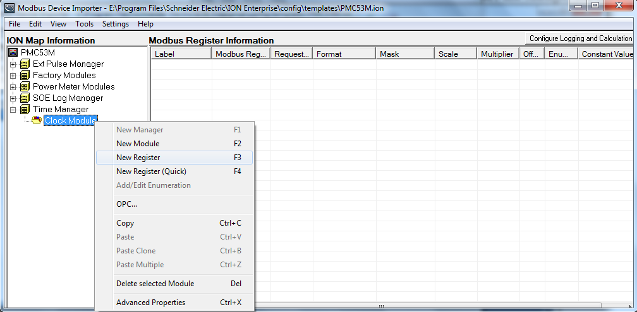

Theregister properties dialog box appears.

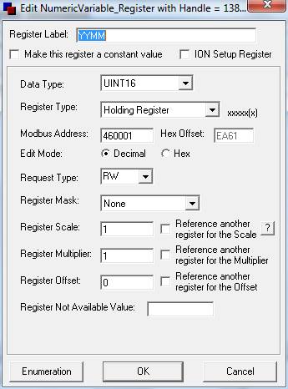

**Register Properties**

* **Register Label:** The label is an identifier for the register. For example, name the register as Vln a to identify the phase A voltage.
* **Data Type:** The data type is used for decoding the values returned from the meter. The selected data type format must match the format delivered by the device. Refer to the Modbus register map for the specific device.
* **Register Type:** It changes the most significant number in the Modbus address to correspond to the specified register type. The register type must match the register type specified by the device documentation.
* **Modbus Address:** This is the physical address of the specified register. It must match the register type specified by the device documentation.
* **Request Type:** This tells the system whether or not it can read, write or do both actions to the specified register. It must match the register type specified by the device documentation.
* **Register Scale:** This specifies what the scale factor of the data being requested should be. It must match the register type specified by the device documentation.

If all necessary parameters are configured, click **OK** and return to the main console. The new register appears under the tree in the left pane and detailed information of the register is shown in the right pane.

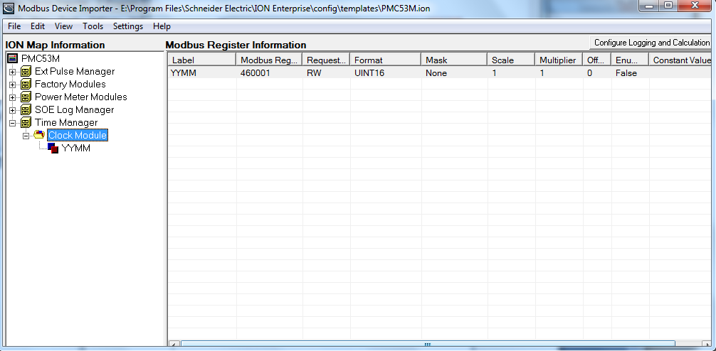

1. Add the other time registers according to the device’s Modbus time registers map.

The following shows all the time registers that have been configured.

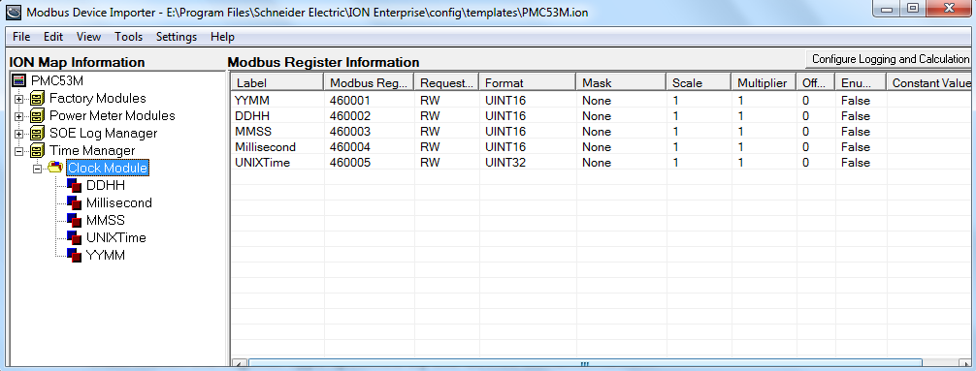

1. After adding all the time registers, first navigate to **File**🡪**Save** to save the template, and select **Tools**🡪**Update Device Type** to update the NOM to reflect these changes.

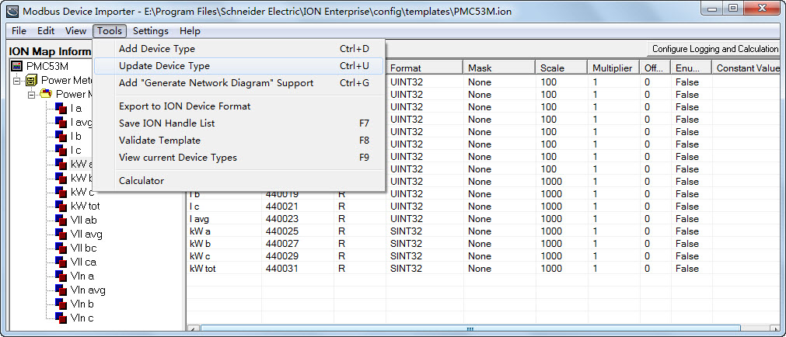

When the hint “Device updated successfully” appears, it indicates that the changes have been updated to the NOM successfully.

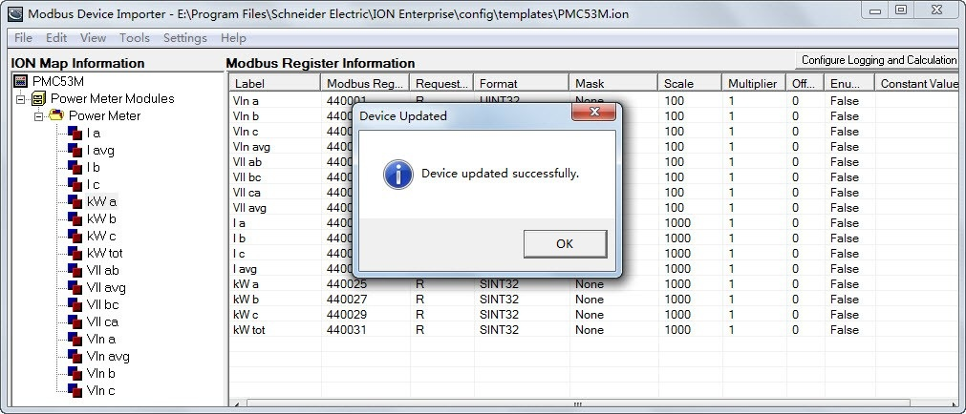

**Setting Up Your Network in Management Console**

1. Launch **Management Console**. Enter the right user name and password to login. Two default user names (“guest” and “supervisor”) are both with a default password of “0” (zero).

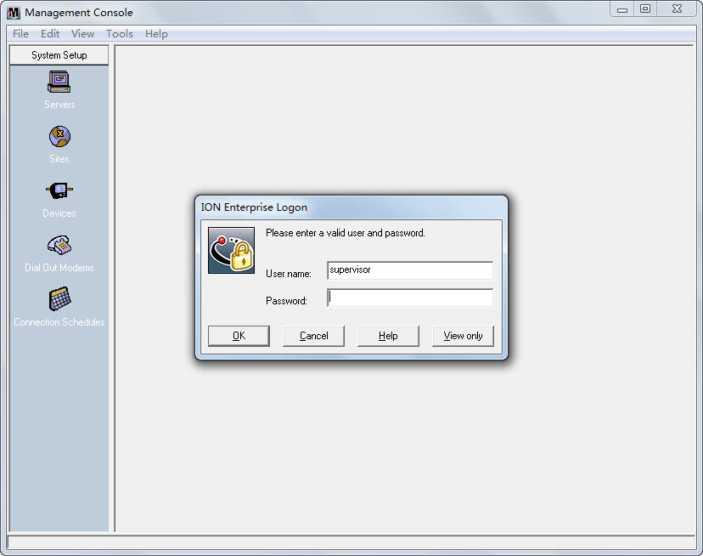

The program interface appears as follows with the default local server:

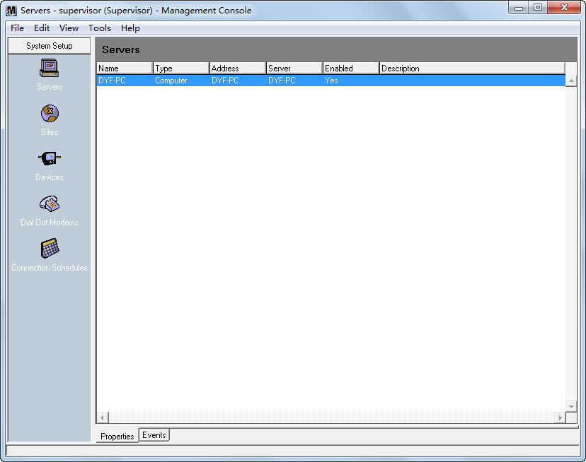

1. Click the **Sites** icon on the left pane. Create and connect to a “Direct Site” with the proper baud rate and serial port.

* Right-click in the display window and select **New**🡪**Direct Site…**.

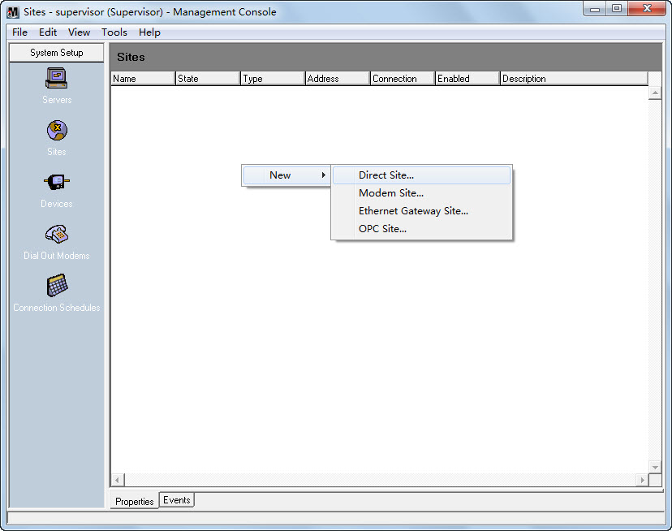

* The **Direct Site Options** dialog box appears as follows:

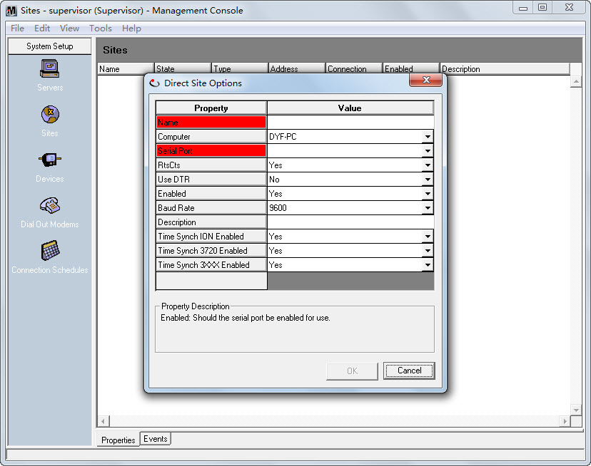

* Right-click within the dialog box and select **Advanced Properties**.

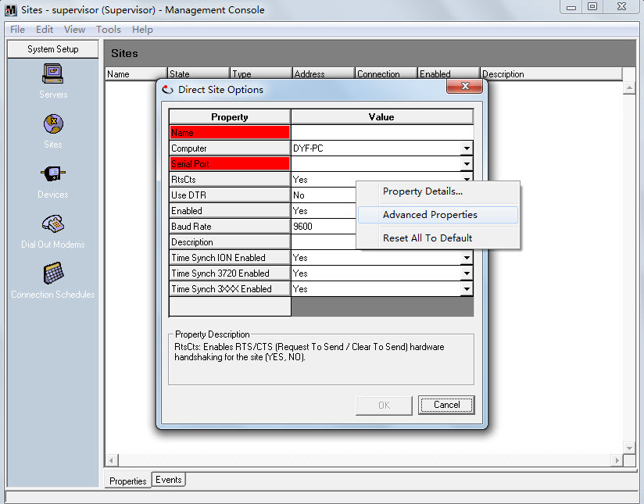

* Fill in the **Name** and **Serial Port** fields. Configure the **Baud Rate**, **Transmit Delay**, **Data Bits**, **Stop Bits**, and **Parity** fields to match the communication settings in the device. Change other fields if required.

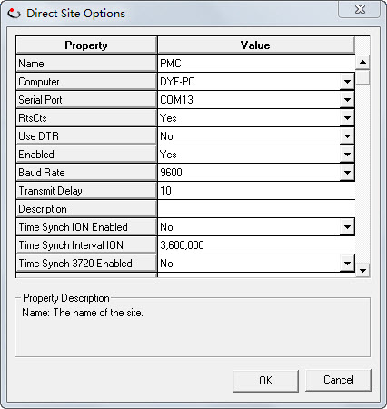

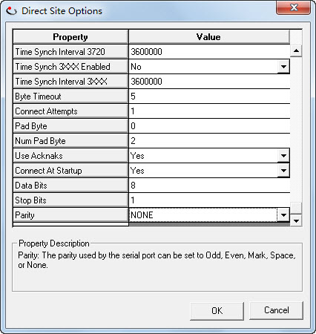

* Right-click on the new site, and select **Connect** to connect the serial site.

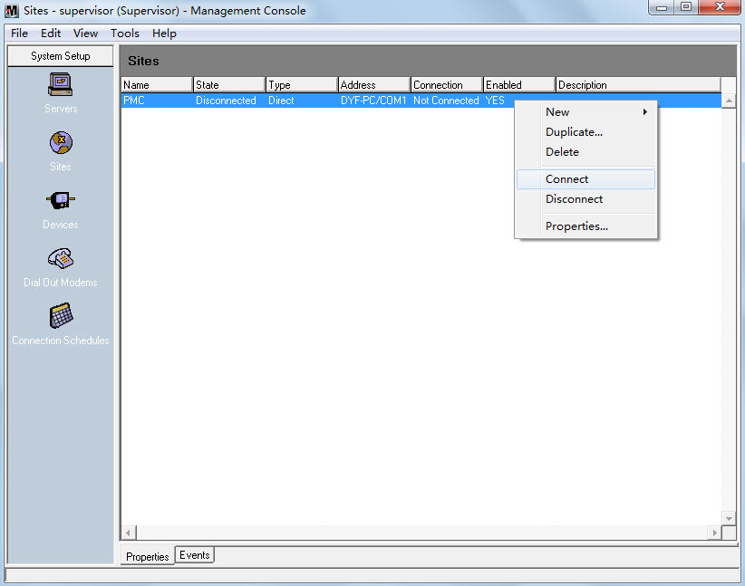

* Select the connection duration type to confirm connect.

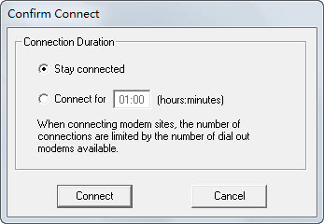

* If the communicate link is OK, it shows **Connected** in the **State** column.

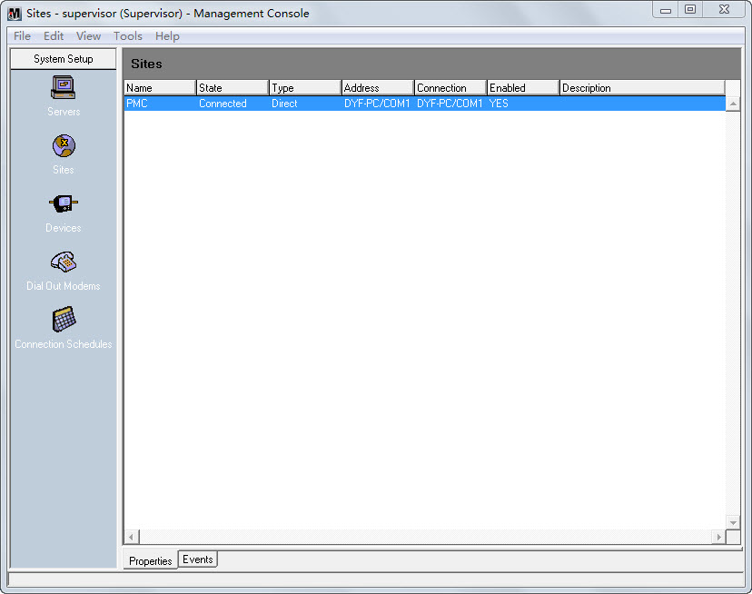

1. Click the **Devices** icon on the left pane. Right-click in the display window and select **New**🡪**Serial Device on Direct Site…**.

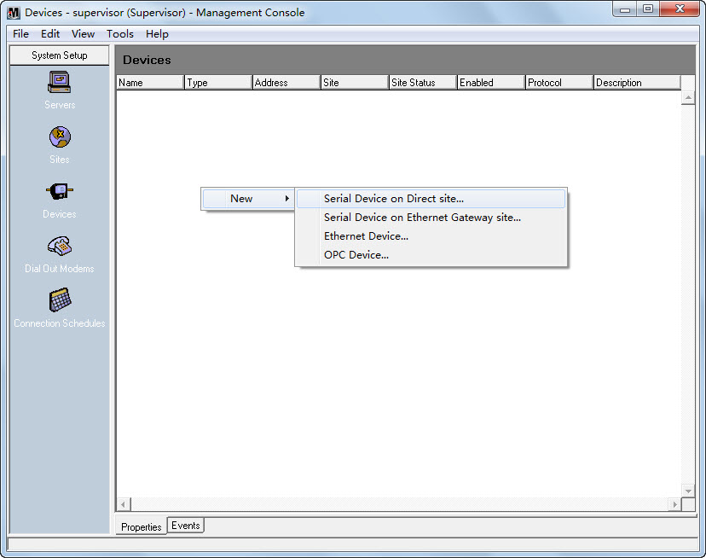

* The **Serial Device Options** dialog box appears as follows:

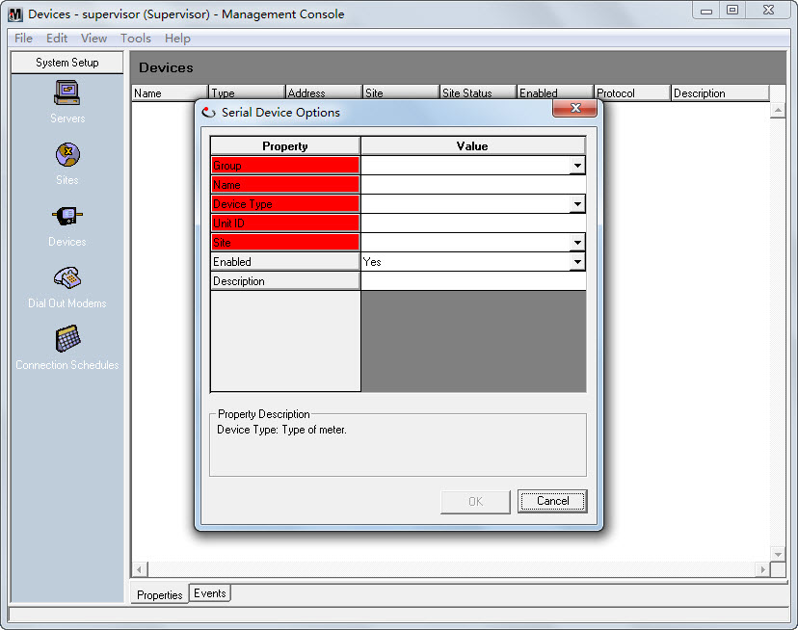

* Right-click within the dialog box and select **Advanced Properties**.

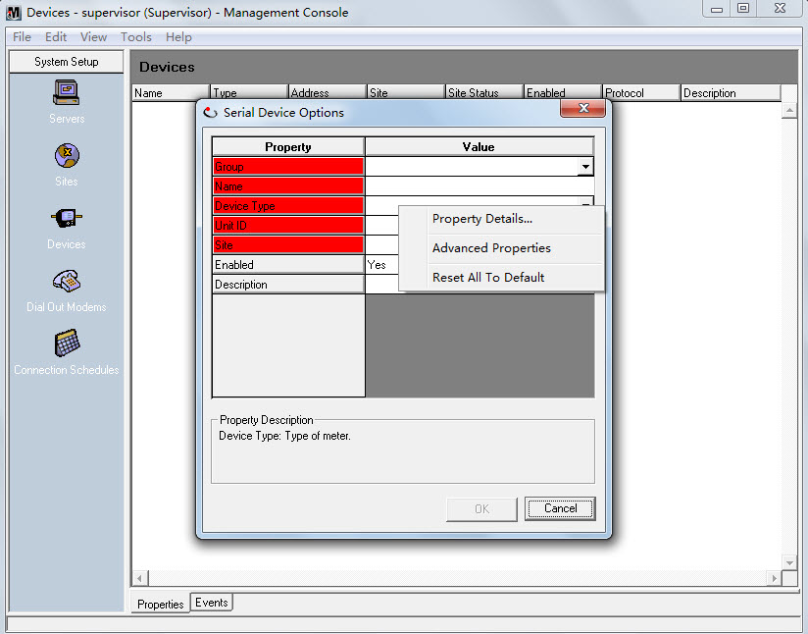

* Fill in the **Group**, **Name**, **Device Type**, **Unit ID** and **Site** fields.

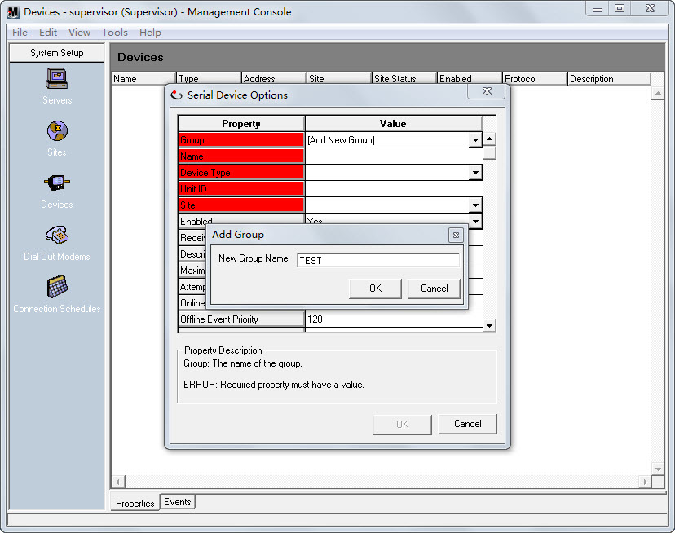

* In the **Device Type** field, click the drop-down button1, you can find the PMC53M device type in the list. Select **PMC53M** for device type.

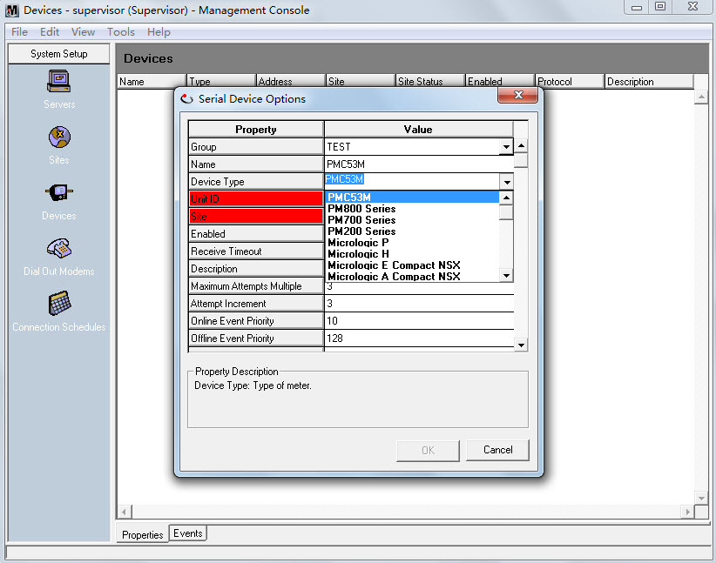

* Configure the **Receive Timeout** and other fields if required.

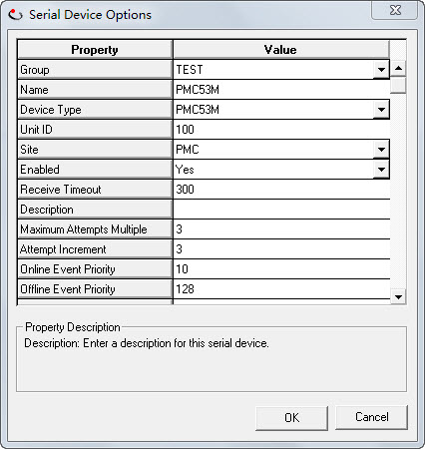

* The PMC53M direct device is shown in the right pane.

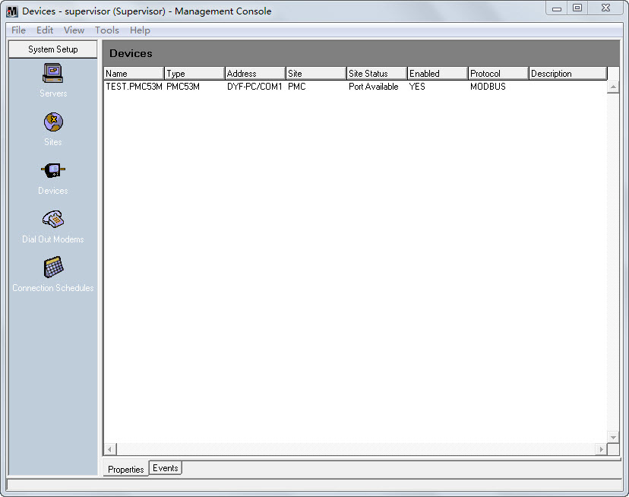

**Setting Up a VIP Diagram in Designer**

1. Launch **Designer** and Open the **VIP** node. Make sure that **Options🡪 Show Toolbox** is selected in order to edit a diagram. Drag a Grouping Object from the toolbox into the VIP diagram. Double-click the grouping object to open it.
2. Create the modules in the picture below.

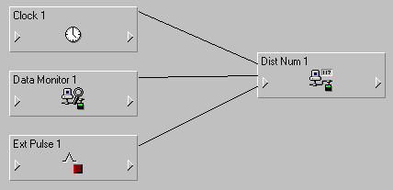

* Drag a **Clock** module and a **Distributed Numeric** module into the window. Link the **LocalTime** output register of the Clock module to the **Source** input register of the Distributed Numeric module.
* Drag a **Data Monitor** module into the window. Click the input symbol of the module, and click the 1.JPG icon on the tool bar. Double-click the PMC53M node and select a proper manager, module and output register to link a real-time parameter of PMC-53M to the **Source** input register of the Data Monitor module. Link the **Status** output register of the Data Monitor module to the **Activate** input register of the Distributed Numeric module.
* Drag a **External Pulse** module into the window. Link the **Trigger** output register of the Ext Pulse module to the **WriteNow** input register of the Distributed Numeric module.
* Right-click the **Distributed Numeric** module to enter the setup interface. Select the **Destination** setup register and then click **Modify…**. Navigate to the **UNIX** time register of PMC-53M as shown below and click **OK**. As shown below.

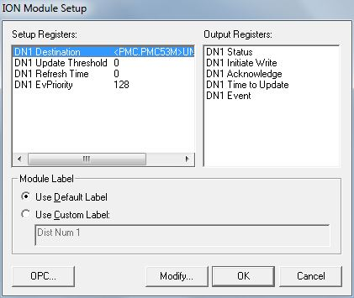

* Save changes to the node and exit.

**Manually triggering time synchronization of PMC-53M in ION VISTA**

1. Launch **VISTA**. Enter the right user name and password to login.
2. Select **File🡪 New** to create a new user diagram. Make sure that **Options🡪 Show Toolbox** is selected in order to edit a diagram.

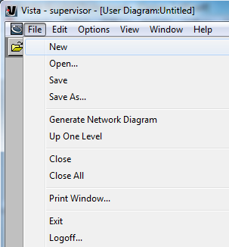

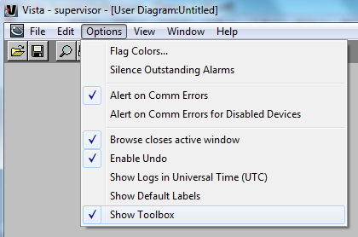

1. Drag a **Control Object** from the tool bar to the diagram.

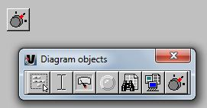

* Right-click on the Control Object and select **Custom🡪ION** under the **Link** tab and click on the **Edit Link…** button.
* Select the VIP node.
* Search for the Ext Pulse Module created in Designer, and select the **Trigger** output register, click **OK** to confirm.

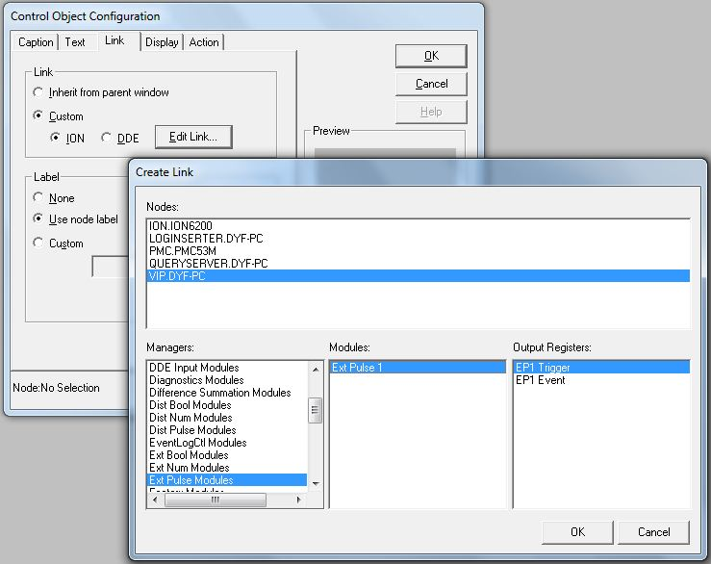

* Now the Control Object is shown as below. Double-click the image and a message box pop-up to prompt the user to confirm. Click **Yes** to send a pulse to trigger time synchronization.

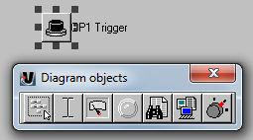

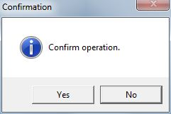

1. Check the data and time from the PMC-53M’s LCD to verify its time synchronization.